CME Top of Book申請書
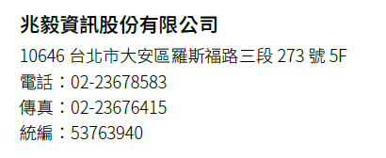

User Information
Cast Id：
Trader's Username*：
Subscriber Name*：
Subscriber Address*：
Subscriber Phone*：
Subscriber Email*：
Username (eSignal/FutureSource)*：
FCM/Broker (Company Name)*：
FCM/Broker Account Number*：
FCM/Broker Primary Contact：
FCM/Broker Phone：
FCM/Broker Email：
附註：*為必填寫的資料

